Date received: Approval:

Study Year Abroad Application Form 2019 – 2020

Application for admission as a tuition fee-paying visiting student

This application form should be completed electronically, then printed and signed by hand.

SECTION 1: Personal Details (as on passport)

Family / Last name: |  | First name(s):
Male/Female/Other: |  | Date of birth: (dd/mm/yyyy)
Nationality: |  | Country of birth:

Permanent Home Address Correspondence Address

1st line of address: |  | 1st line of address:
2nd line of address: |  | 2nd line of address:
Town/City: |  | Town/City:
Zip/Post code: |  | Zip/Post code:
Country: |  | Country:
Telephone No.: (including country code) |  | Telephone No.: (including country code)
E-mail address: |  | E-mail address:

SECTION 2: Academic Details Please indicate desired period of study: Deadline for application:

☐Academic year (23/09/2019 – 01/06/2020)
☐Semester 1 (23/09/2019 – 21/01/2020)
☐Semester 2 (22/01/2020 – 30/05/2020)
1st May 2019
3rd June 2019
1st October 2019

Current studies

Home university: |  | Expected completion date:
Date of entry: |  | Qualification aimed for (e.g. Bachelor of Art,  Bachelor of Science)
Current year of study: | - First ☐ Second  - Third ☐ Postgraduate | Academic major/minor:

SECTION 3: Visa Information

Passport Number: |  | Passport Issue Date:
Passport Expiry Date: |  | Place of Issue:

Do you require a visa in order to study in the UK? | - Yes | - No
Have you previously studied in the UK? | - Yes | - No
If yes, please specify below
Course Start Date : |  | Course End Date:
Institution Name: |  | Course Type:

Have you previously been refused a visa? ☐ Yes ☐ No

SECTION 4: Proposed programme of study at Aberystwyth University

Provisional Module Choices

Students are advised to research modules by visiting https://www.aber.ac.uk/en/modules/. Chosen module codes should be entered on the application form (the full module title is not required).
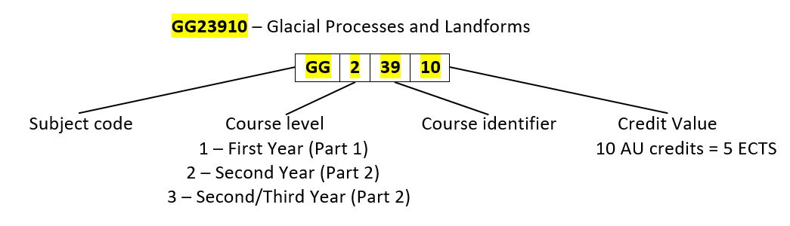
Modules are given codes as follows:

Incoming students are advised to consider Part 2 Modules, as these are likely to be of an appropriate level.

Aberystwyth University students will usually take 120 credits in a year and around 60 per semester. This is equivalent to 60 European Credit Transfer System (ECTS) per year and 30 ECTS per semester.

It is the responsibility of the home institution to determine how many credits and modules are appropriate for conversion purposes. Please note that selecting modules totaling over 60 credits or from different departments will increase the likelihood of timetabling clashes. Modules that are listed as having 00 credits are run over both semesters and would therefore be unsuitable for students only studying at Aberystwyth for one semester. Where pre-requisite courses are listed for a module, students are advised to contact the Module Coordinator to check their suitability.

Modules listed on the Application form are not guaranteed – students will still need to register on arrival and some modules may have changed from those listed. Students will be provided with guidance during registration if this is the case. Chosen module codes should be entered below (the full module title is not required and it may not be necessary to fill all boxes).

First choice of Semester 1 Modules: | Reserve choice of Semester 1 Modules: | First choice of Semester 2 Modules: | Reserve choice of Semester 2 Modules:

SECTION 5: Home institution approval of application

Please ask your Study Abroad Advisor or Personal Tutor at your home institution to sign below to confirm their approval of your application.

Name: |  | Signature:
Position: |  | Date:

SECTION 6: Financial support

Please state how your place at Aberystwyth University will be financed if you are accepted. Note that 50% of the total tuition fees must be paid before your will be issued with documents allowing you to apply for your visa.
Scholarships & Bursaries: | Description | £ Amount | Student Loan/Financial Aid: | Description | £ Amount
Private sources:  (e.g. Parental support) | Description | £ Amount | Other: | Description | £ Amount

SECTION 7: Further information

Additional Support
Do you have a disability, learning difference, health or medical issue?

    - Yes
    - No

If you selected “Yes”, the information will be shared with the Accessibility Team who will advise you on any reasonable adjustments that can be made in order for you to fully engage with your course of study at Aberystwyth University.

SECTION 8: Accommodation

Aberystwyth University is able to guaranteed accommodation for students participating in the Study Year Abroad programme.
As soon as your place to study at Aberystwyth University is confirmed you will be contacted to apply for accommodation. To qualify for guaranteed accommodation you must apply by 1st August. Please note that a place in university accommodation is guaranteed but not a specific type of room or location and that Accommodation Licence Periods do apply.

Please note: If you are a second semester incoming student you will be contacted around the end of October with information regarding how to apply for University Accommodation.

SECTION 9: Additional documentation

Please submit the following documents along with your completed application:

Short essay (200 words) explaining why you would like to study at Aberystwyth University
      - Letter of recommendation from a member of staff at your home institution
      - Certificate of English Language Ability (if English is not your first language)
      - Transcript of grades from your home institution
      - Scanned copy of your passport

SECTION 10: Declaration

Aberystwyth University will not share your personal data with third parties outside of contractual or legal obligations without your consent. For complete information about how Aberystwyth University’s International Office treats your personal information, please read our Data Protection Information before submitting your application.
I have read above referenced Data Protection Information, and agree that Aberystwyth University can contact me and send me information that will be relevant to my application.

In the event of, and in consideration of, the University accepting me as a student, I hereby undertake to pay, as and when due, all University fees. I understand that payment of 50% of the tuition fees must be made following my initial acceptance.

I hereby certify that all the above information is correct and complete, and I desire to apply for admission as a student of the University and declare that, if admitted, I shall conform to all the Rules & Regulations of Aberystwyth University.

Signature: Date:

